2024 Business Insurance Senior Leadership Meeting

Opening Sizzle Reel

High energy music (Van Halen-esque). Fast transitions. Energetic feel.

Segment | Text | Visuals
Intro | Business Insurance Senior Leadership Meeting  Execution, Resilience and Transformation | 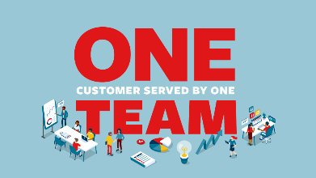
Perform | Last Year’s Challenge was Sustaining Our Outperformance. | Photo of Greg on stage from last year.
 | And despite continued market headwinds…  ECONOMIC INFLATION  SOCIAL INFLATION  VOLATILE WEATHER  REINSURANCE | Montage depicting the headwinds:  Inflation: Headlines  Social Inflation: Headline; Headline; Headline  Weather: Hurricane Helene; 2024 Tornados
 | This Year, You Stepped Up | Confident office worker.
 | Staying VISIBLE with agents and brokers | TLC and CIAB footage and images.
 | Staying TRUE to underwriting excellence
 | Staying RESILIENT in a tough marketplace
 | Working TOGETHER to win
Transform | Sustained performance…  …while investing for the next generation | 3C visuals  CUSTOMER SOLUTIONS  CONVENIENT PROCESSES  COMPETITIVE COST STRUCTURE  
 | Advancing our BI transform priorities  - Underwriting Modernization  - Sales Excellence  - Product Sophistication  - Analytics Advantage | Visual treatment of words with modern stock video.  https://www.shutterstock.com/video/clip-1064392879-4k-abstract-speed-motion-highway-road
Our People | Our success today and tomorrow is fueled by you | Photo Montage using photos from field visits and events.
Close | Together, we have no limits  Together, we win  Together, we are ONE TEAM | https://www.shutterstock.com/video/clip-1036604402-hartford-connecticut-aerial-v5-traveling-panoramic-view

